**Celestini 2019**

**Section - E**

i) 100 balls are tossed independently and at random into 50 bins. Let X be a random variable representing the number of empty boxes. Find the expected value of random variable X, i.e. E(X).

**Answer**:

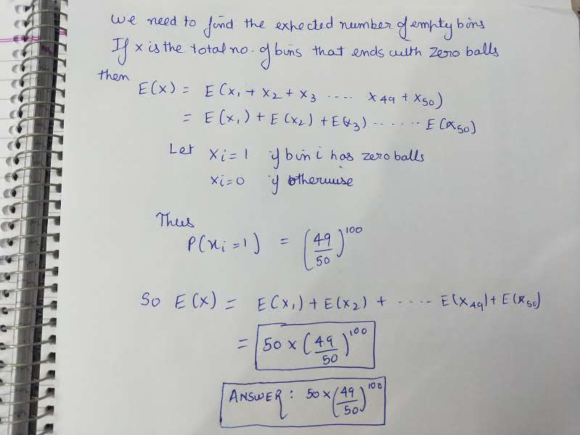

ii) Binary communication channel



ii) a) What is the expected number of erroneous bits in a block of 1000 bits?

**Answer**:

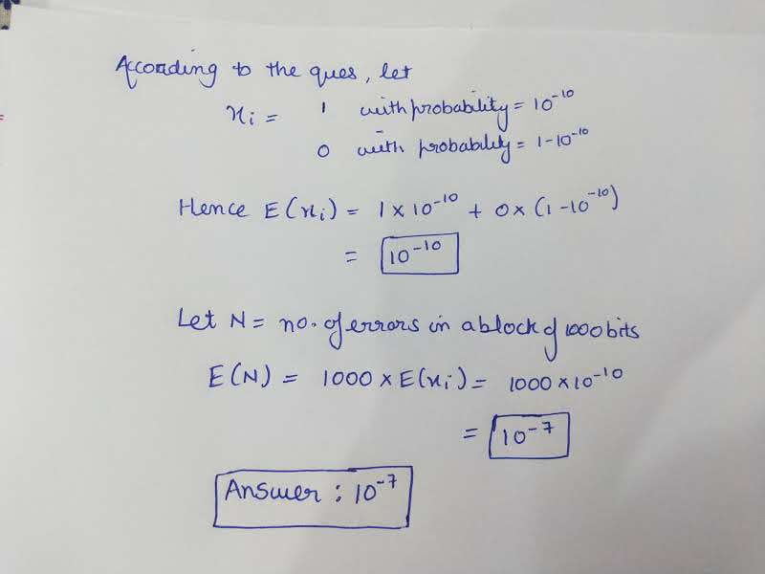

ii) b) Find an upper bound on the probability that a block of 1000 bits has 10 or more erroneous bits.

**Answer**:

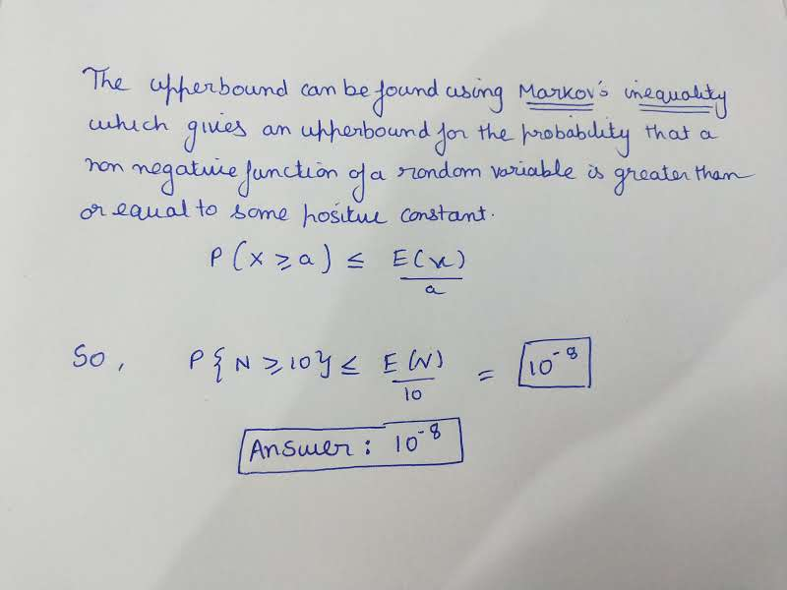

iii) Alina gambles against Gina. Each night Alina draws a card from a deck (with replacement). If it is a spade or a queen, Alina wins $4. If not, Alina loses $1. What is Alina’s total expected winnings after 30 nights?

**Answer**:

